Energy efficient teaching-learning-based optimization for the discrete routing problem in wireless sensor networks

All sensors run on battery power and they consume battery while sensing and sending data to base station by using neighbour node routing and this routing has to be chosen accurately to avoid energy consumption as if senor loose more energy then battery will exhaust soon and sensor will be died. To overcome from this issue many nature inspired algorithms are introduced such as PSO, ANT and many more which will take all available neighbours of sensors as POPULATION and then evaluate fitness in terms of energy consumption and transmission delay and whatever neighbour sensor take less energy consumption or nearest in distance will have less transmission delay and energy consumption so such neighbours will be selected.

Existing PSO and ANT has to evaluate or tune their parameters for best neighbour selection this tuning will consume more energy and to overcome from this problem TEACHER LEARNER based optimization was introduced which will not tune any parameters simply execute themselves continuously to optimize neighbour selection. This optimization will take less delay, overhead and energy consumption

To implement this project we don’t have any sensor environment so we implemented this project as SIMULATION where sensor nodes will select best optimized neighbour using PSO, ANT and TLBO algorithms.

SCREEN SHOTS

To run project double click on ‘run.bat’ file to get below output screen

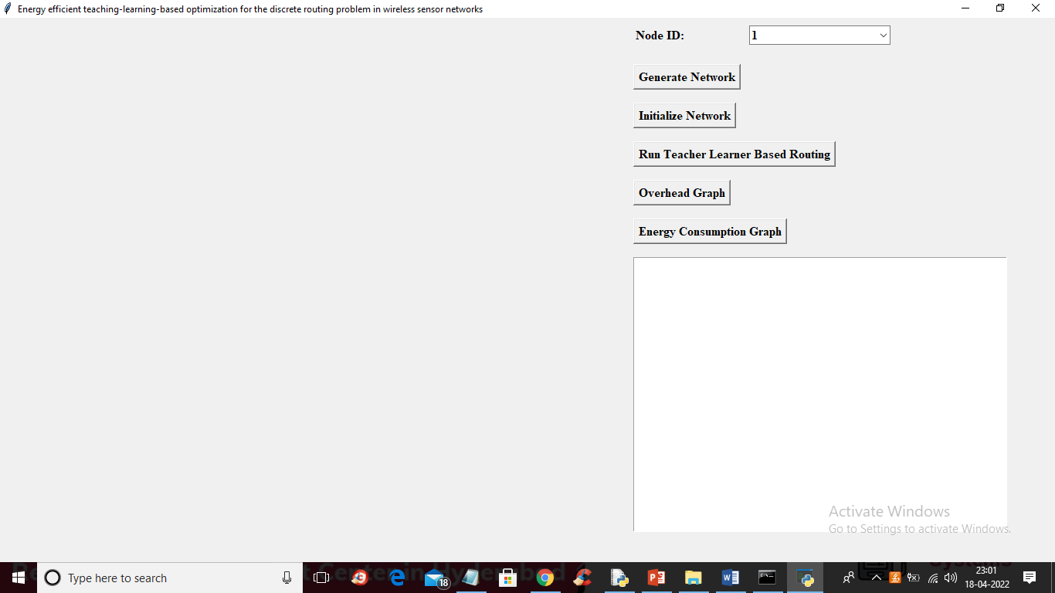

In above screen click on ‘Generate Network’ button to generate some dummy sensors like below screens

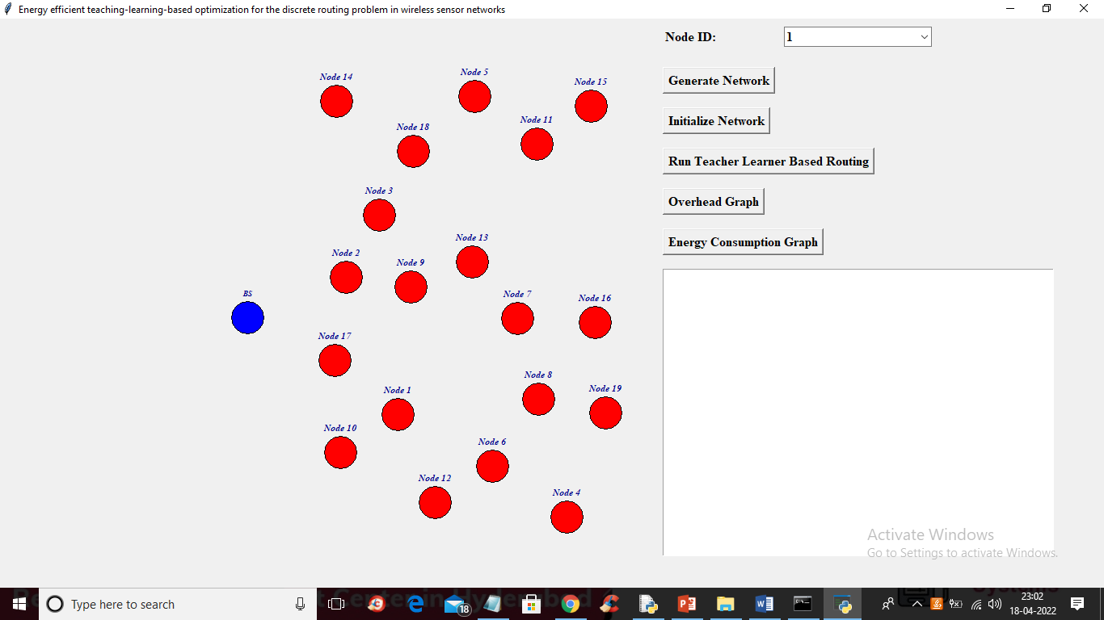

In above screen all red colour circles act like sensors and blue colour node is the base station and all red colour sensor will sense and send data to base station by using nearest routing nodes. Now click on ‘Initialize Network’ button to find parent nodes which are closer to base station or to find node which accept data from sensor and send to base station

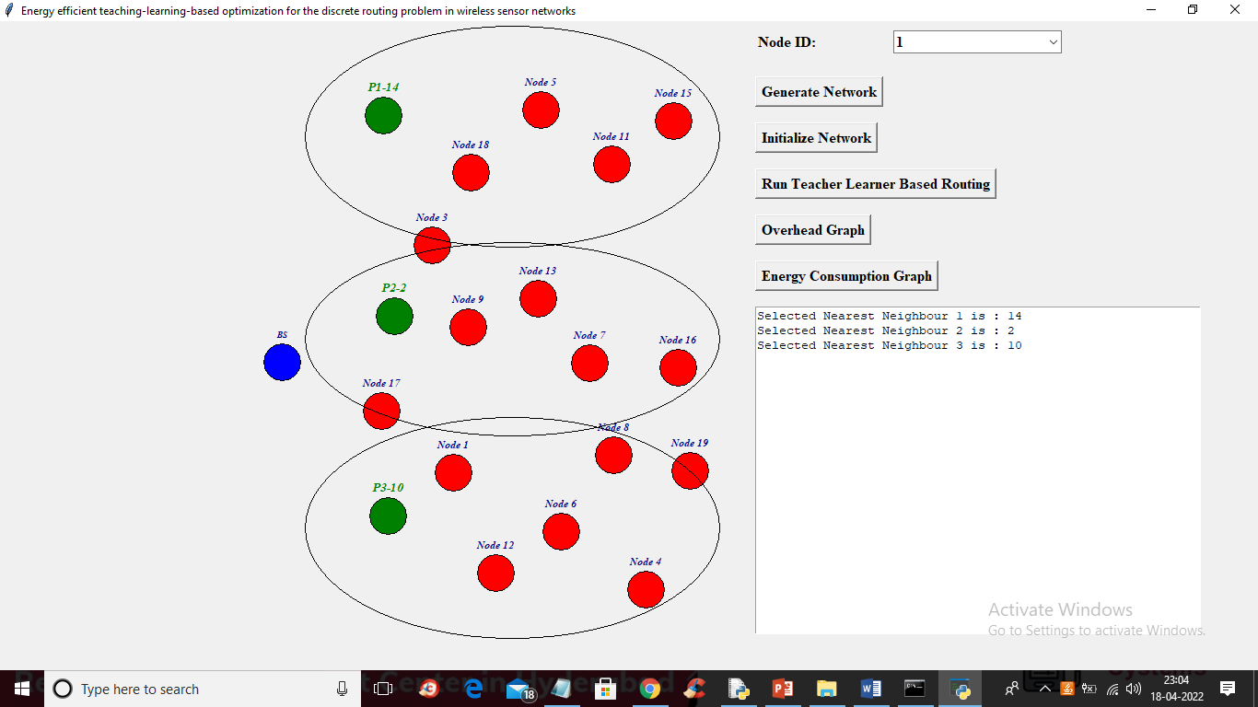

In above screen green colour nodes are the closer nodes to base station which will take data from red colour sensor and send to base station as base station always received data from head node so all green colour nodes are the head nodes and big oval represents which sensors will used which head node to send data to base station. Now select any sensor from drop down box to send data to base station

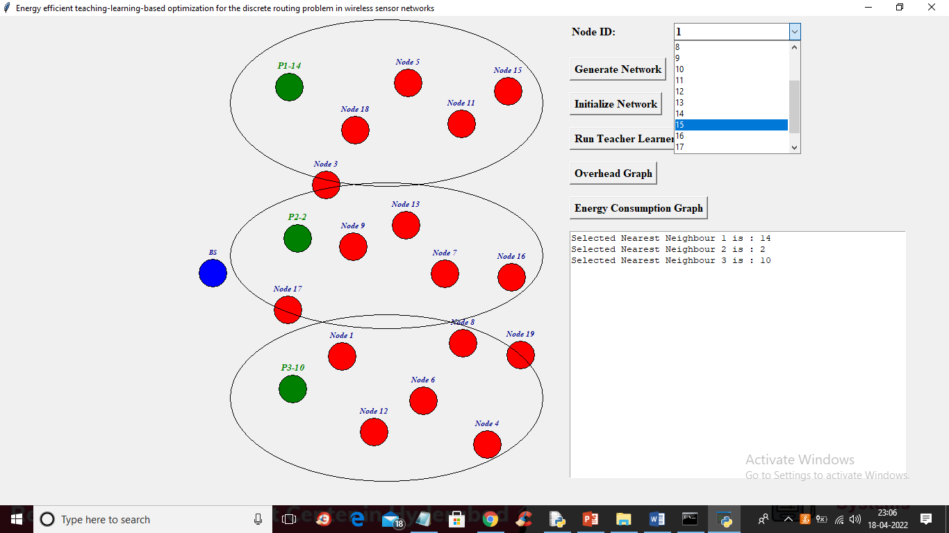

In above screen I am selecting 15th sensor to send data to base station and now TLBO algorithm will select best routing neighbours or optimize neighbours to send data to head node and head node will send to base station. Now after selecting sensor click on ‘Run Teacher Learner Based Routing’ button to send message like below screen

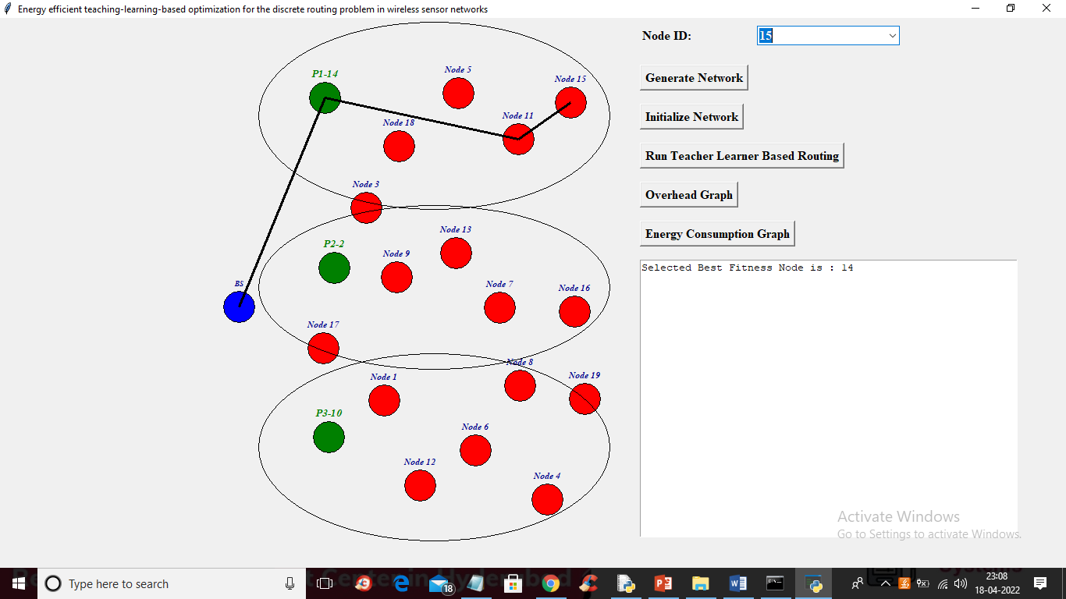

In above screen we can see sensor 15 chosen Node 11 as the best routing node and node 11 send data to head node P1-14 and P1-14 sending data to base station. Similarly you can select any sensor and then routing will perform using TLBO algorithm and now click on ‘Overhead Graph’ button to get below graph

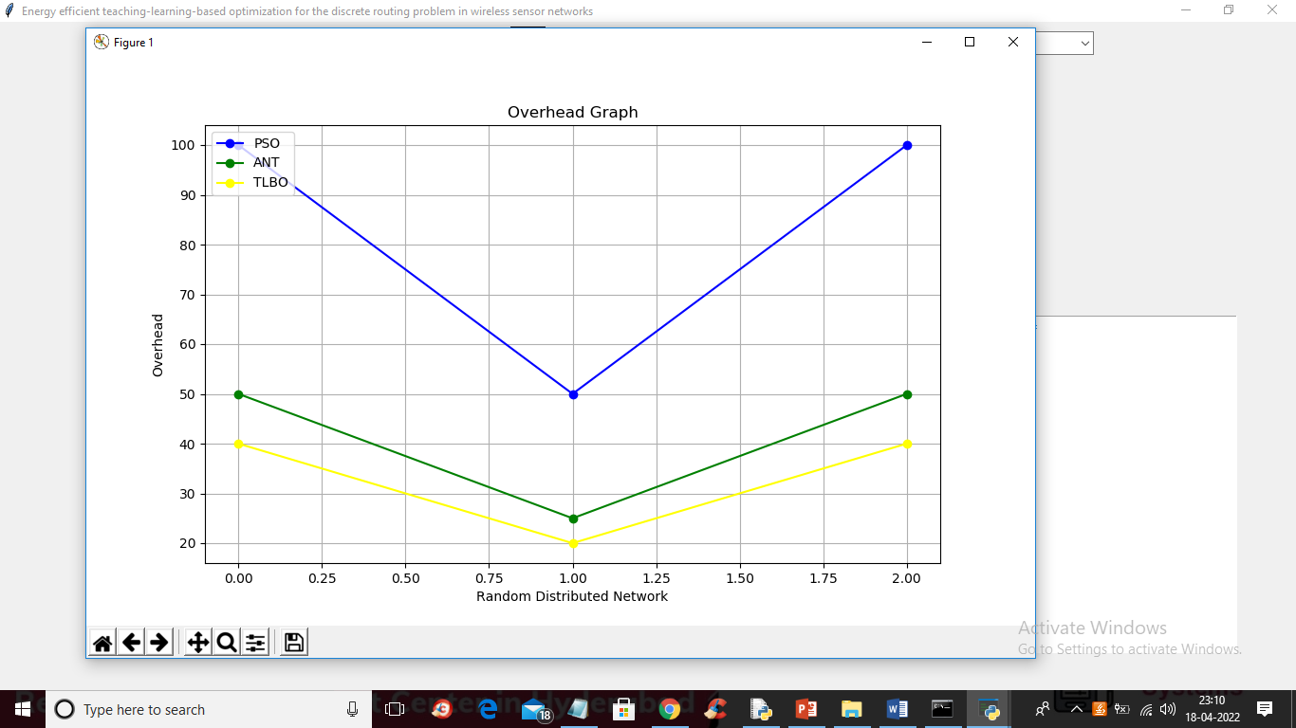

In above graph blue line represents ANT overhead and green line represents PSO over and yellow line represents TLBO and in all algorithms TLBO has less overhead and now click on “Energy Consumption” graph button to get below graph

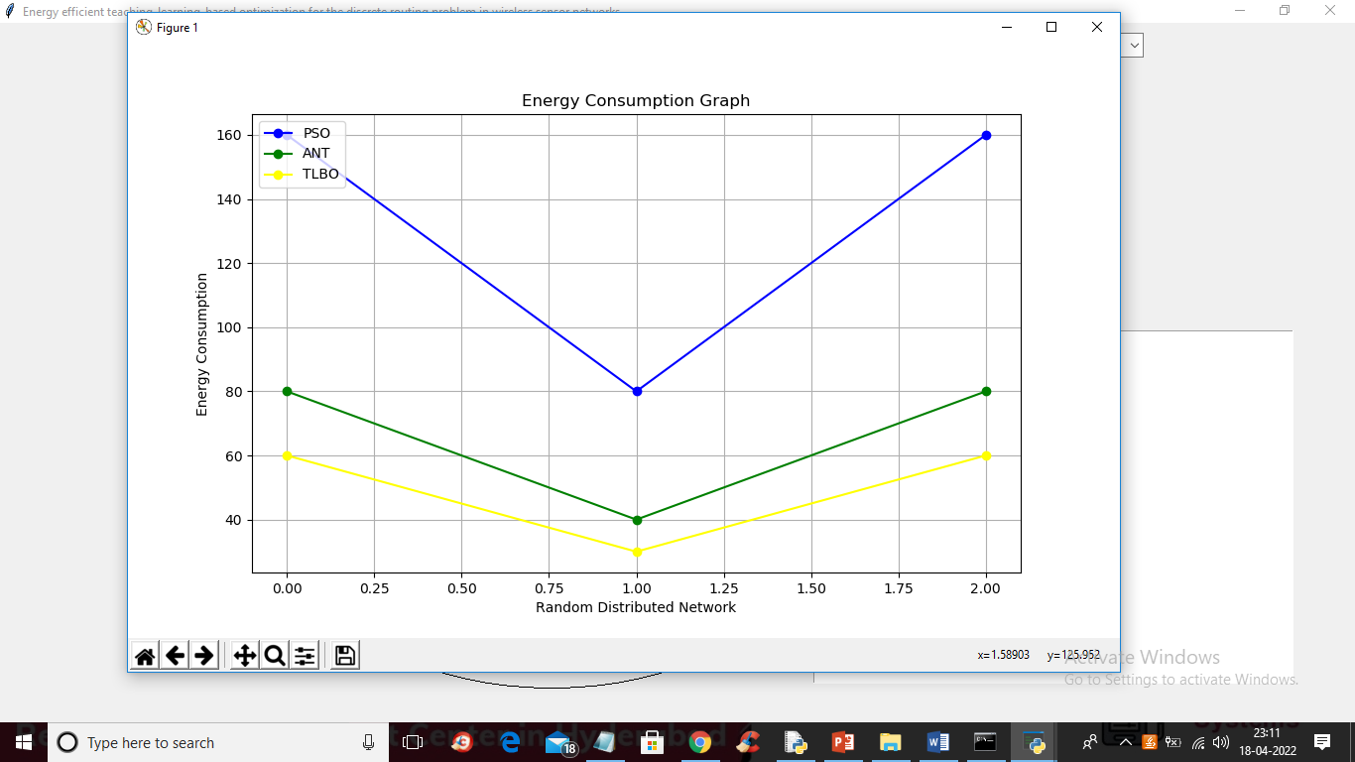

In above graph we can see PSO and ANT consume more energy compare to TLBO algorithm so TLBO is better than PSO and ANT